House (from <https://www.house.gov/legislative-activity> )

Feb 14, 18 – 21, 28

Mar 7, 13-14, 28

THAT’S AS FAR AS THE SCHEDULE GOES ON THIS SITE, BUT THEN THERE’S THIS…

<https://pressgallery.house.gov/schedules/2025-house-calendar> FROM STEVE SCALISE

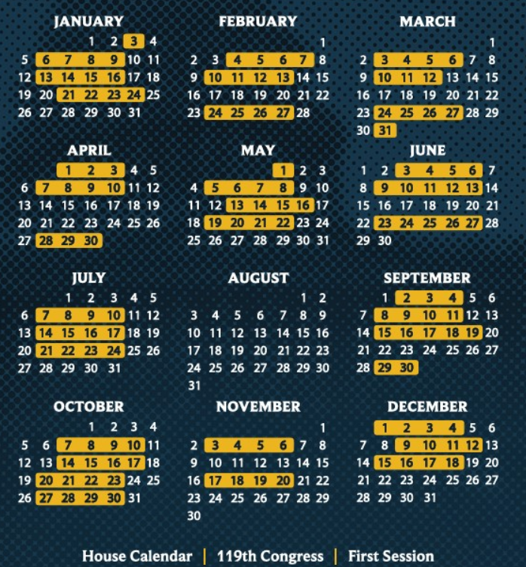

Apr 11, 14-25

May 2,9,12, 23, 27-30

Jun 16-18, 20

Jul 1-3, 11, 18, 25, 28-31

Aug the whole month

Sep 5, 12, 22-26

Oct 13, 24, 31

Nov 7, 10, 12-14, 21, 4-26, 28

Dec 5, 8, 19, 22-24, 26, 29-31

Senate <https://www.govinfo.gov/content/pkg/CCAL-119scal-2025-02-19/pdf/CCAL-119scal-2025-02-19.pdf>

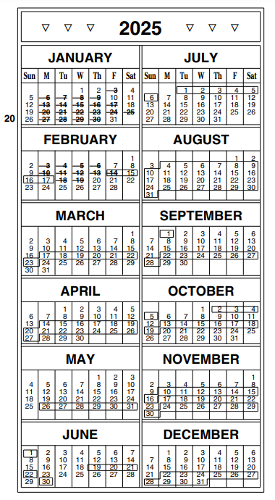

Feb 15-16

Mar 17-21

Apr 14-18,19-23

May 26-30

Jun 20, 30

Jul 1-3

Aug whole month

Sep 23-26

Oct 2-3, 13-17

Nov 10, 12-14, 24-26, 28

Dec 22-24, 26, 29-31

\*Federal holidays 2025

1/1 New Year’s

1/20 MLK

2/17 Presidents

3/31 Cesar Chavez

5/31 Memorial

6/19 Juneteenth

7/4 Independence

9/1 Labor

10/6 Frances Xavier Cabrini

11/11 Veteran’s

11/27 Thanksgiving

12/25 Christmas